Small Business - Team 3

Galo Guerra, Jiahua Zhang, Andrew Wang, Xingru Chen

Deliverable 4

Analysis and Key Questions:

Our group was tasked with finding answers to the key questions of what businesses exist in District 4, and what businesses are overrepresented. In our research, we determined that we could categorize businesses in two ways. For most businesses, this meant using their NAICS 2-digit identifier, such as Healthcare and Social Assistance businesses. However, two specific 2-digit categories, Retail Trade and Other Services, we felt were too broad and thus split these into their NAICS 6-digit identifiers. This ended up giving us 58 different business types to analyze that were present in Boston’s District 4:

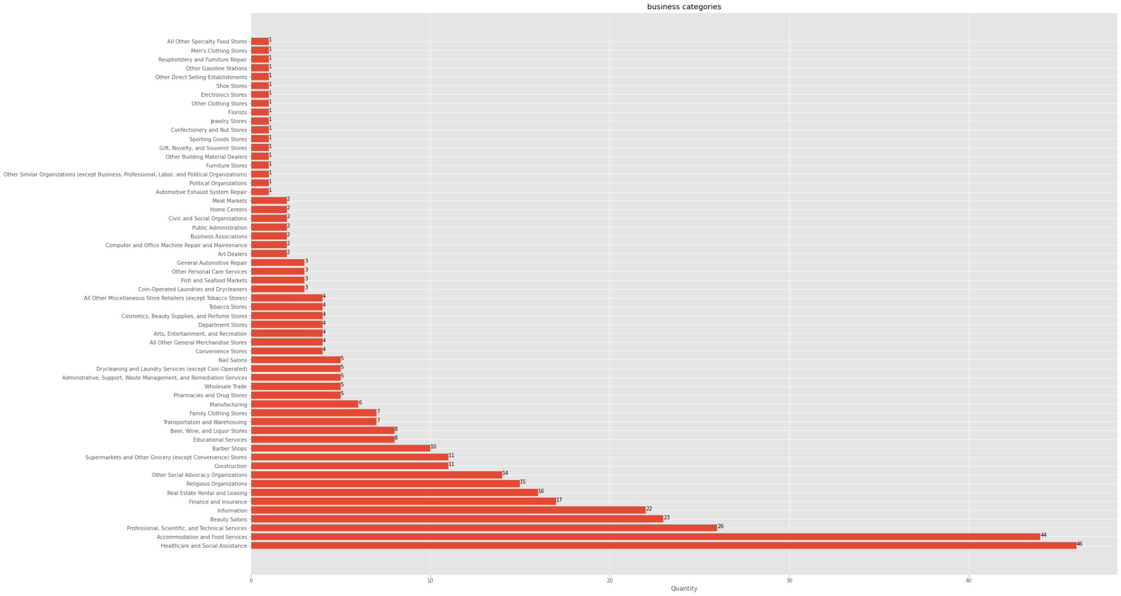

Notable amongst these businesses were the following categories: Healthcare and Social Assistance with 46 businesses, Accommodation and Food Services with 44 businesses, Professional, Scientific, and Technical Services with 26 businesses, Beauty Salons with 23 businesses, and Information with 22 businesses. These businesses are the most represented within District 4, and are all contenders for being overrepresented in District 4. However, most notable is Beauty Salons, as this is the only 6-digit identifier that is in the top 5. This is probably the most clear answer for what business is overrepresented, as it is the only very specific identifier that contends with the less specific identifiers numerically.

From there we mapped the most common businesses within district 4, assigning each to a color to provide a clear view of how these businesses are laid out. As well, we created two centroids in order to provide a clearer picture of how close the business types are to one another:

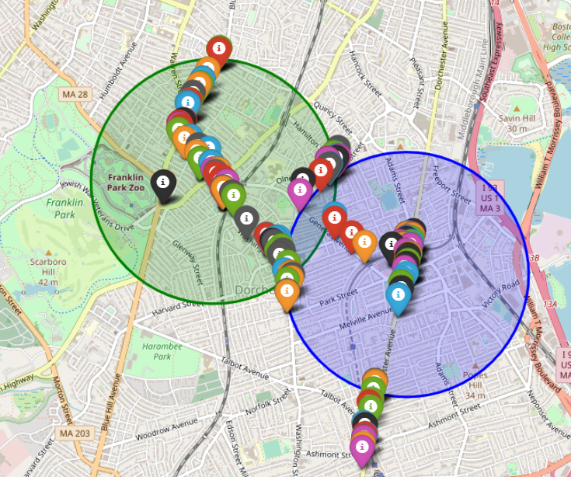

From there, we were able to compare the results in district 4 to those in other districts. In comparison to the other 8 districts, we see a lot of similarities in the most frequently seen businesses. We created a graph to see the number of businesses in all other districts first:

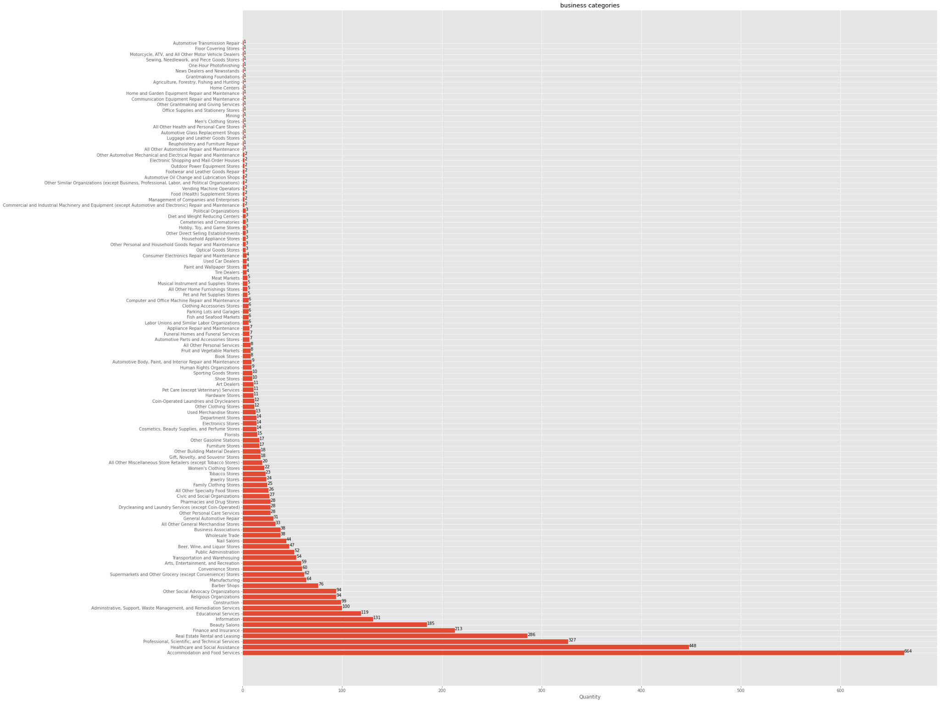

Fram there, we separated the largest categories and created a multiple bar graph that shows every district, and the five most represented business types in every district:

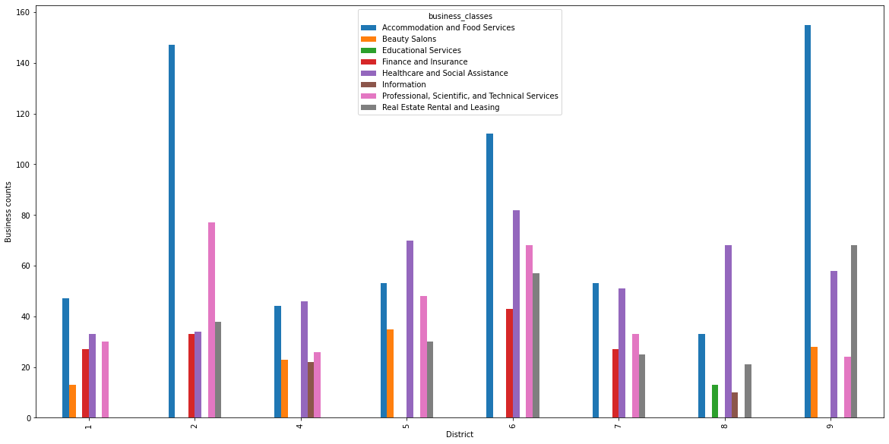

Notably, all districts share: Accomodation and Food Services, Healthcare and Social Assistance, and Professional, Scientific, and Technical Services. As well, districts 1, 5, and 9 interestingly share the category of Beauty Salons. This was surprising as it appears that maybe Beauty Salons could be viewed as overrepresented over multiple districts. Interesting to note is that only District 8 has educational services in its top 5 categories.

As per the client’s request, we took a deeper look at two large 2-digit categories. Those being Educational Services and Professional, Scientific, and Technical Services. We created new graphs to display the breakdown of these two categories. First is the Educational Services:

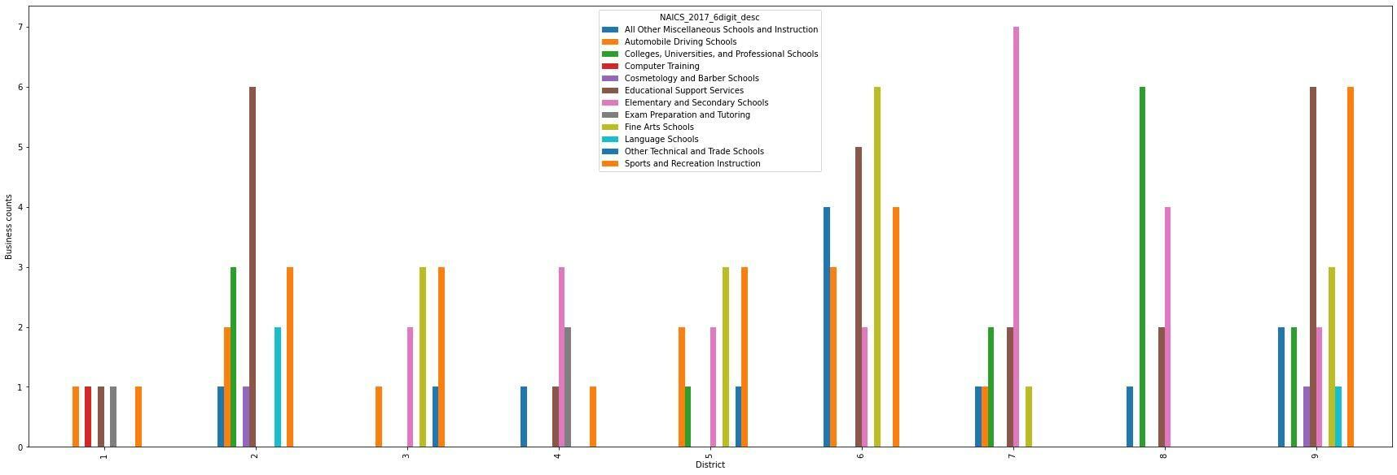

One thing to note is that no district has more than 7 of any 6-digit type of Educational Services. As well, we see that the majority of the educational services in district 8 are Universities, and this tracks as district 8 contains Back Bay and the surrounding universities. For district 4, its two largest forms of education are Elementary and Secondary Schools, and Exam Prep and Tutoring. Overall though, district 4 trends toward the bottom of the list in terms of number of businesses of this type.

The other category we were asked to look further into was Professional, Scientific, and Technical Services. Originally, our group created a graph of every single 6-digit business of this category. Of note from that graph. is that district 6 has over 30 Public Relations Agencies, while the next closest to that number is district 5 with less than 20 Public Relations Agencies. The full breakdown of every single type of Professional, Scientific, and Technical Services business was too hard to read, so we then created a chart that displayed only the most prominent ones:

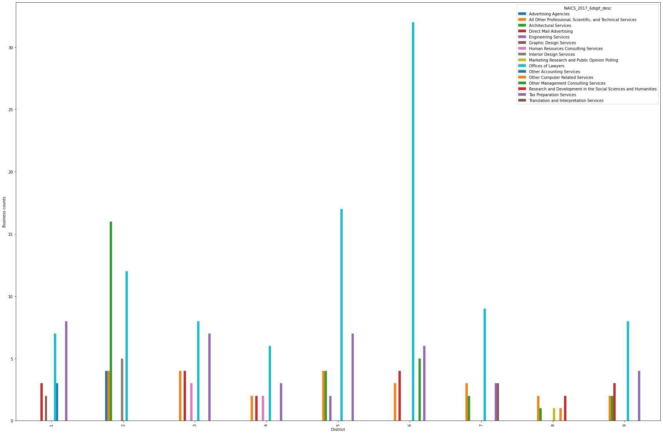

Of note is that district 4 still stands far and away noticeable with over 30 Offices of Lawyers. For district 4, it's interesting to note that no single type of Professional, Scientific, and Technical Services business was overtly prominent. Despite being one of the most prevalent business types from our original findings, it appears that this is not due to any specific type of business, and is more widespread over a multitude of these 6-digit descriptions.

As well, it was tasked to us to create measures for the number of businesses per capita in every district and all of Boston. Here is the results we gathered:

|  | Population | Number of Businesses | Businesses per Capita | People per business |
| --- | --- | --- | --- | --- |
| District 1 | 76,830 | 292 | 0.0038005987244565925 | 263.1164383561644 |
| District 2 | 77,466 | 652 | 0.008416595667776831 | 118.81288343558282 |
| District 3 | 73,285 | 505 | 0.006890905369448045 | 145.11881188118812 |
| District 4 | 72,917 | 388 | 0.005321118532029568 | 187.93041237113403 |
| District 5 | 75,436 | 538 | 0.007131873376106899 | 140.21561338289962 |
| District 6 | 76,523 | 814 | 0.010637324725899403 | 94.0085995085995 |
| District 7 | 72,147 | 418 | 0.005793726696882754 | 172.60047846889952 |
| District 8 | 76,370 | 229 | 0.0029985596438392038 | 333.49344978165936 |
| District 9 | 74,673 | 631 | 0.008450176101134278 | 118.34072900158479 |
| Total | 675647 | 4467 | 0.00661144058953862 | 151.2529661965525 |

Extension Project:

For our extension project, our group chose to look at Boston’s 2010 Climate Social Vulnerability Data. This dataset provides information on different types of vulnerable populations in Boston (such as the elderly, children, minorities, low income households, etc.), and provides their locations based on the 2010 census tracts. We were able to use this data to map out the census tracts located in Dorchester and Mattipan, the two largest parts of District 4:

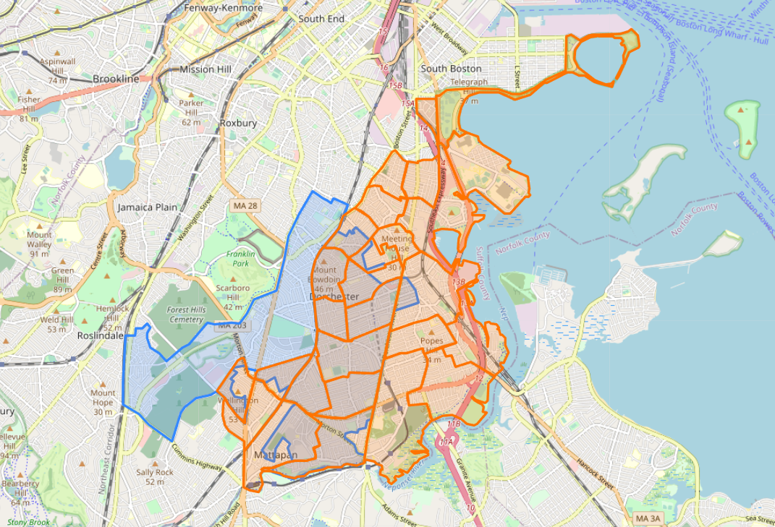

From there, we were able to find the overlap of the vulnerable populations and District 4:

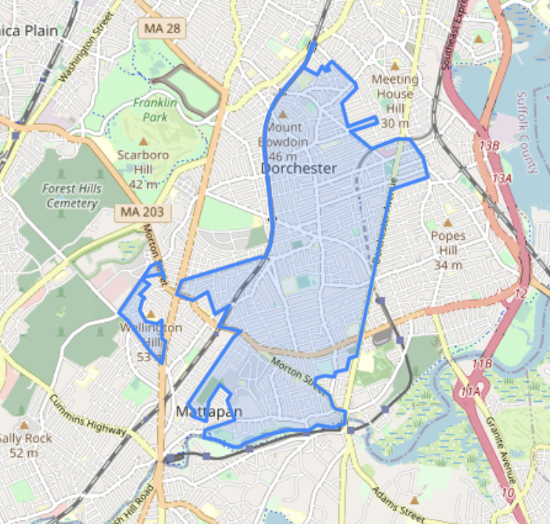

After getting access to the shapefiles for all districts, we were then able to map out the numbers of vulnerable populations for every district:

District 1:

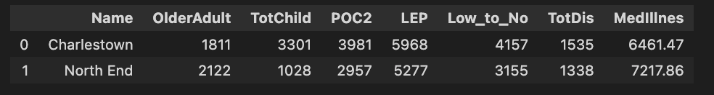

District 2:

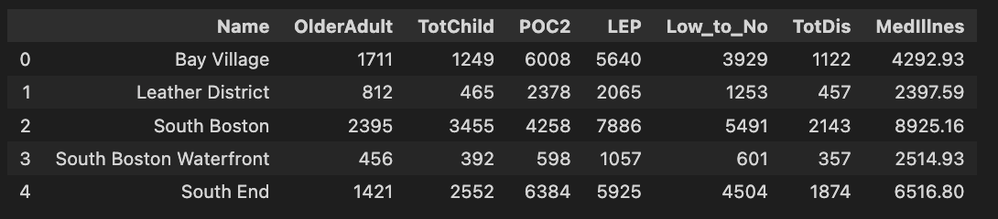

District 3:



District 4:



District 5:

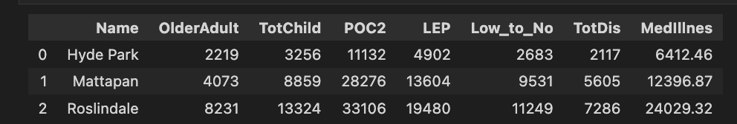

District 6:

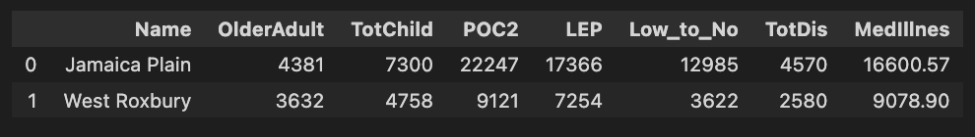

District 7:



District 8:

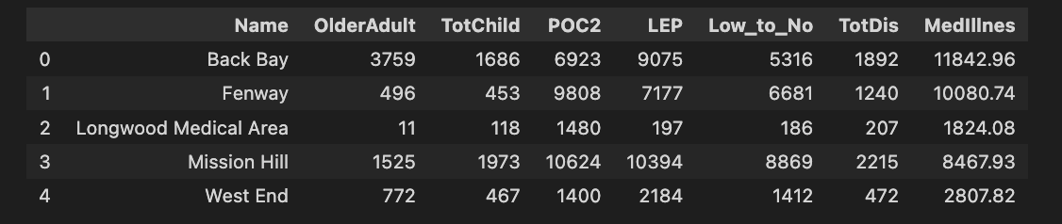

District 9:

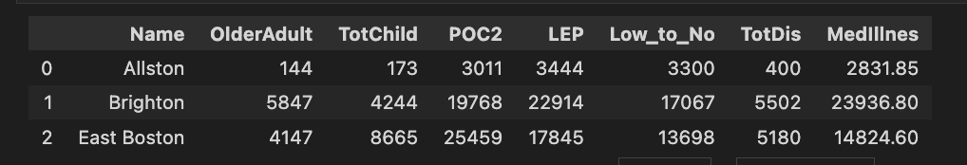

Our final steps for the Final Report is to create graphs that show the proportion of each vulnerable population in every district. The goal is to compare how much every single vulnerable population is represented in every district, and also to provide a clearer picture for the numbers seen above.